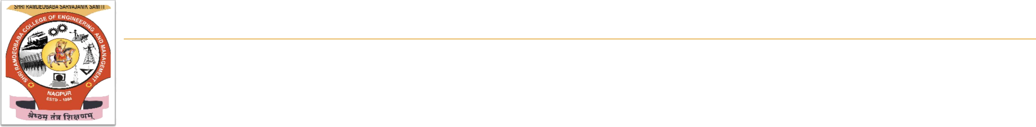

**Shri Ramdeobaba College of Engineering & Management**

**Department of Computer Science and Engineering**

**SIGN LANGUAGE VIDEO GENERATION FROM AUDIO/TEXT**

# Introduction

Deaf people are a cultural-linguistic minority. For thousands of years, they have experienced oppression from the majority group hearing people. They are deprived of the things that normal people do easily like attending gatherings, playing online games, attending online video conferences, etc. The main purpose of our project is to develop an app/website where the normal person can communicate with the deaf people. Here we are taking the audio as our input and then we are converting the audio into the text and then we are converting this text into ISL language and after this we are generating the video by combining the videos of the various words of the ISL language as our output.

It is very important for the deaf people to have access to sign language as it plays a very crucial role in their social, emotional and linguistic growth. Sign language is a combination of hand shapes, orientation, and movements of the hands, arms or body, and facial expressions.

# 

# Aim and Objectives

The proposed system will consist of a web based application where the user will give audio as the input and then the system will internally convert the given audio into text then text into ISL grammar and then will create the video of the converted text and generate the video as the output.

. 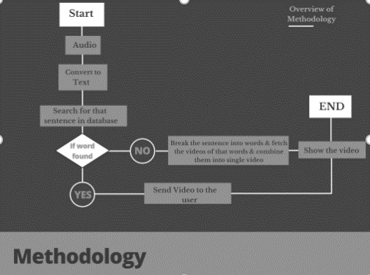

# Methodology

* Audio/Text input in Hindi or English
* History generation
* ISL language video output

# Technology & Tools

* 1. Python3.6 : Python is a high-level, interpreted, interactive and object-oriented scripting language.
  2. Django : Django is a Python-based free and open-source web framework that follows the model–template–views architectural pattern.
  3. Quasar : Quasar Framework is an open-source Vue.JS based framework for building apps.
  4. NLP : Natural language processing is a subfield of linguistics, computer science, and artificial intelligence concerned with the interactions between computers and human language, in particular how to program computers to process and analyze large amounts of natural language data.
  5. Google Speech Reorganization API : Google Cloud Speech API enables developers to convert audio to text.
  6. OpenCV : OpenCV is a library of programming functions mainly aimed at real-time computer vision
  7. SQLite : SQLite is a relational database management system contained in a C library.
  8. JavaScript : JavaScript is high-level, often just-in- time compiled, and multi-paradigm. It has curly-bracket syntax, dynamic typing, prototype-based object-orientation, and first-class functions.

***Results***

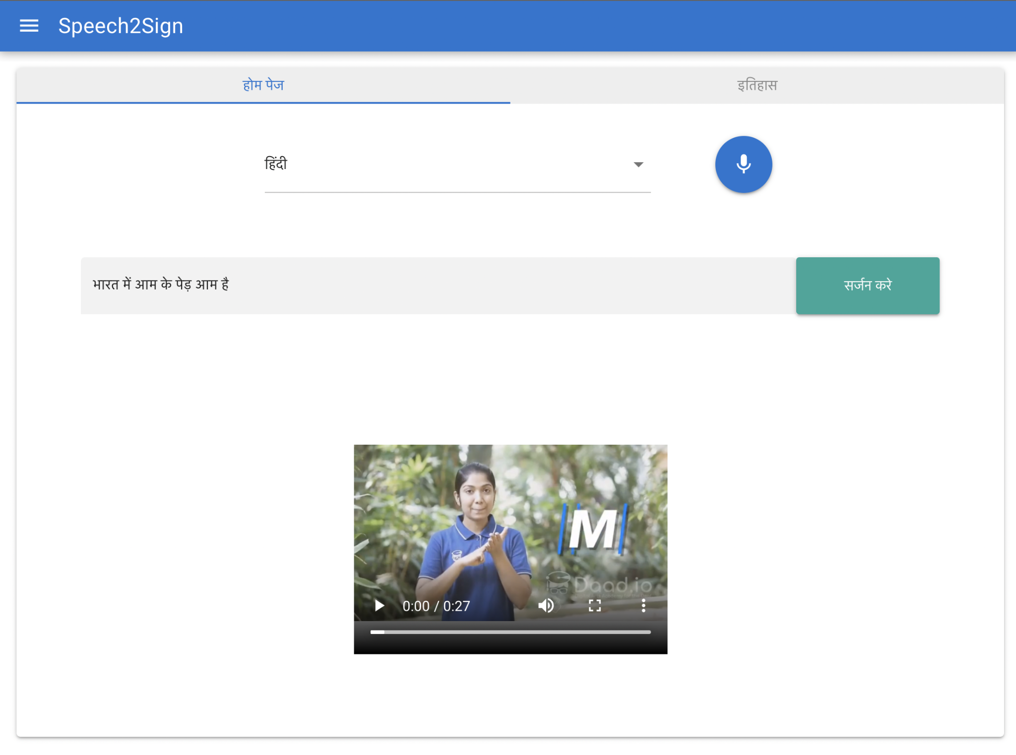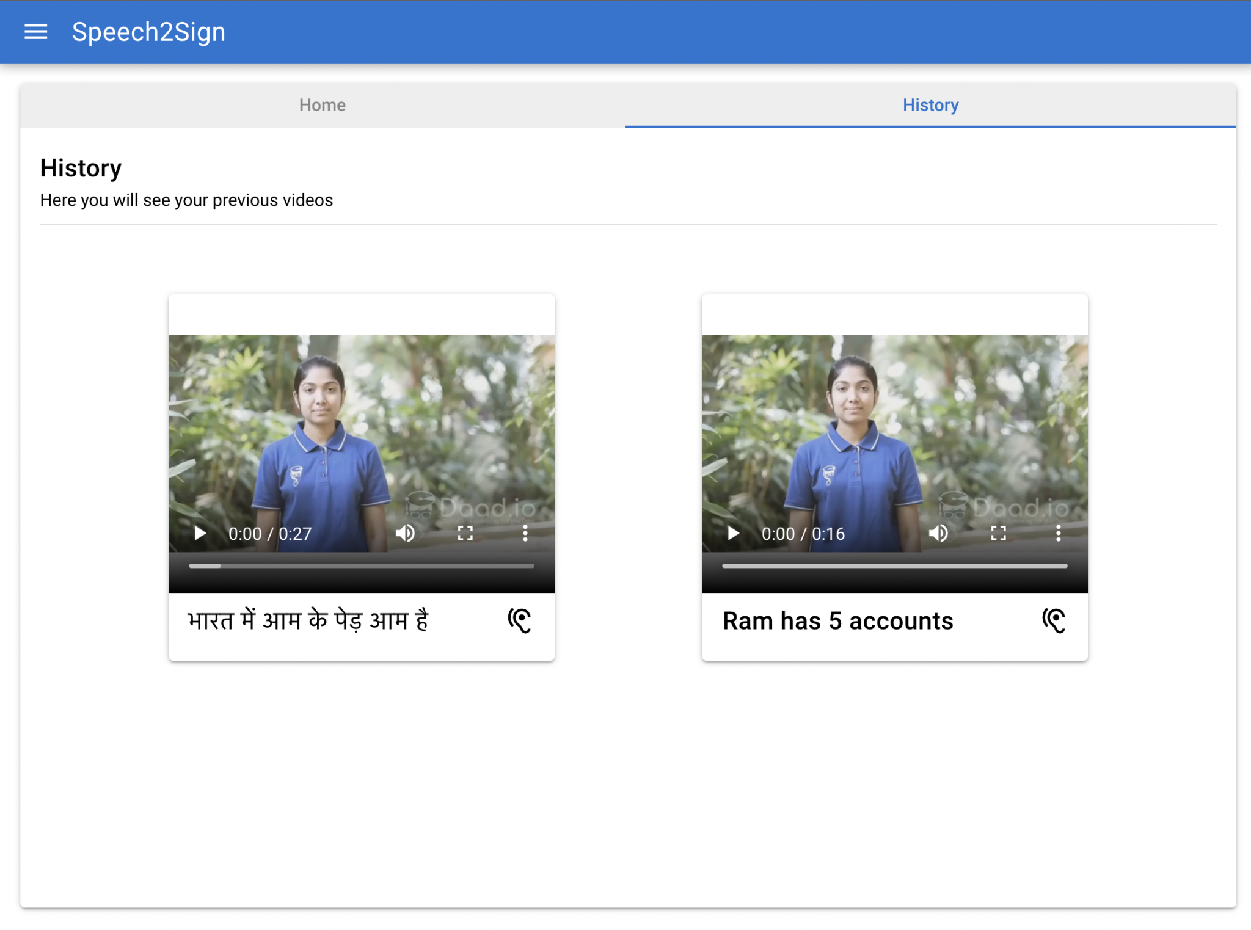

***Video link***

<https://drive.google.com/file/d/1EyzhRbLfEGPhWpTDrqOitxwnIYbOm5uD/view>

# Conclusion

Our app/website can be very useful in the various platforms; like in online web conferences we can used our app/website to translate the voice of normal person into ISL language and there will be a separate section where the video converted in ISL language will be displayed, it can also be used in journalistic translations for converting the news into ISL language which deaf people can understand because there is no such feature is available to translate the news in ISL language, the news channels are just using a person who is live and translating the live news.

Along with these it can also be used in various sectors; like in schools, colleges, online conferences, railway stations, bus stops, hospitals, etc.

# Acknowledgements

**Dr. A. J. Agrawal**

**Prof. S. G. Mundada**

**Computer Science and Technology,**

**Shri Ramdeobaba College of Engineering and Management**

# Group Members

**89 Arpit Khare**

**58 Nikhil Likhar**

**61 Om Patre**

**54 Mohit Shingane**

**78 Smit Kukadapawar**